Contents

Index

1. SYNOPSIS 2

2. INTRODUCTION 4

3. SYSTEM REQUIREMENTS 5

4. DESIGN 6

5. CODE 7

6. SCREENSHOTS 29

7. REFERENCE AND BIBLIOGRAPHY 32

8. CONCLUSION 33

# 1. SYNOPSIS

The Online Comic Reading website is used for assisting readers to read the comic books over the web with more convenience.

It provides wide range of comics to reader.

**Hardware Specification :**

* 256MB or above of RAM for a single-computer website.
* 85MB of storage or above

**Software Specification :**

* XAMPP Application
* Notepad
* Browser

**Existing System :**

In the conventional system a comic reader has to go to the shop to purchase comics and read them . Reader search the comic he/she wants to read if they find it they will have to pay the money to shopkeeper to buy it.

**Problems With Existing System :**

* In the existing system reader have to go to the shop to purchase a comic book.
* If the comic they want is not available in the shop then they have to go to next shop if required.
* If reader cannot go to shop then that will be problematic.

**Proposed System :**

The Online Comic Reading website is useful for comic readers to read the comics from their Personal Computers while sitting home. It provides wide range of comics to reader. Online Comic reading is more convenient.

**Basic Design :**

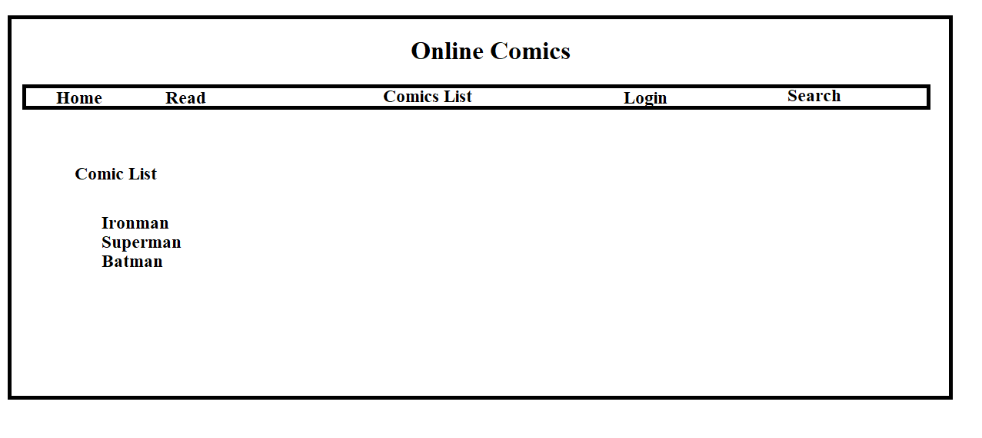

**Conclusion :**

So this website has provided us with new comic reading experience. It is fast and more efficient to use.

# 2. INTRODUCTION

**Existing System :**

It is manual system comic reader has to go to shop to purchase the comics to read it. Reader search the comic he/she wants to read if they find it they will have to pay the money to shopkeeper to buy it.

**Problems With Existing System :**

* In the existing system reader have to go to the shop for comics
* If comic they want is not in the shop then they have to go to next shop if required
* If reader cannot go to shop then that will be problematic.
* It is time consuming
* It requires extra work

**Proposed System :**

The Online Comic Reading website is used for assisting readers to read the comics with more convenience. It provides wide range of comics to reader. Reader can directly access from their home.

Any person can read the comics. It is not limited to certain type of people. It provides fast and smooth comic reading experience.

All details will be available on a click. Reader just need internet connectivity to access the website and he/she can read the comic from anywhere

# 3. SYSTEM REQUIREMENTS

**Hardware Specification :**

* 256MB or above of RAM for a single-computer website.
* 85MB of storage or above

**Software Specification :**

* XAMPP Application
* Notepad
* Browser

# 4. DESIGN



# 5. CODE

**Index.php**

<?php

session_start();

?>

<html>

<head>

<title>Index page</title>

<meta name="description" content="website description" />

<meta name="keywords" content="website keywords, website keywords" />

<meta http-equiv="content-type" content="text/html; charset=windows-1252" />

<link rel="stylesheet" type="text/css" href="style/style.css" />

</head>

<body>

<div id="main">

<div id="header">

<div id="logo">

<div id="logo_text">

<h1><a href="index.html">Comic Alliance<span class="logo_colour"></span></a></h1>

<h2>Read Comic books online</h2>

</div>

</div>

<div id="menubar">

<ul id="menu">

<li class="selected"><a href="index.php">Home</a></li>

<li><a href="readsect.php">Read comics</a></li>

<li><a href="register.php">Sign Up</a></li>

<li><a href="contact.php">Contact Us</a></li>

<?php

if(!isset($_SESSION['login']))

{

?>

<li><a href="login.php">Login</a></li>

<?php

}

else

{

?>

<li><a href="logout.php">Logout</a></li>

<?php

}

?>

</ul>

</div>

</div>

<div id="site_content">

<div id="content">

<div><img src="jl.jpg" width="100%" height="100%"></div>

<img src="avenger.jpeg" width="20%" height="25%">

<img src="dc.jpeg" width="20%" height="25%">

<img src="daredevil.jpeg" width="20%" height="25%">

<img src="dc2.jpg" width="20%" height="25%">

</div>

</div>

<div id="content_footer"></div>

<div id="footer">

<p><a href="index.php">Home</a> | <a href="readsect.php">Read comics</a> | <a href="login.php">Login</a> | <a href="register.php">Sign Up</a> | <a href="contact.php">Contact Us</a></p></div>

</div>

</div>

</body>

</html>

**register.php**

<?php

error_reporting(0);

session_start();

?>

<html>

<head>

<title>Index page</title>

<meta name="description" content="website description" />

<meta name="keywords" content="website keywords, website keywords" />

<meta http-equiv="content-type" content="text/html; charset=windows-1252" />

<link rel="stylesheet" type="text/css" href="style/style.css" />

<style>

form{

border-style: inset;

width:600px;

font-size: 15px;

font-family: cursive;

color: #222222;

}

input[type=text], input[type=password] {

width: 150px;

padding: 4px 15px;

margin: 8px 0;

display: inline-block;

border: 1px solid #ccc;

box-sizing: border-box;

}

button {

font-family: "Times New Roman", Times, serif;

font-size: 12px;

background-color: #E1E1E1;

color:#121212;

padding: 10px 12px;

margin: 4px 0;

border-style: outset;

cursor: pointer;

width: 70px;

}

.cancelbtn,.signupbtn {

float: left;

width: 70px;

}

.clearfix::after {

content: "";

clear: both;

display: table;

}

.error{ color:red; }

</style>

</head>

<body>

<?php

$fn=$_POST["fn"];

$ln=$_POST["ln"];

$gen=$_POST["gender"];

$eid=$_POST["email"];

$pswd=$_POST["pswd"];

$pswd2=$_POST["pswd2"];

$fnameErr =$lnameErr= $emailErr = $genderErr = $fnameErr2 =$lnameErr2= $emailErr2 =$pswdErr=$pswd2Err=$pswdErr2="";

function test_input($data)

{

$data = trim($data);

$data = stripslashes($data);

$data = htmlspecialchars($data);

return $data;

}

if ($_SERVER["REQUEST_METHOD"] == "POST")

{

if (empty($_POST["fn"]))

{

$fnameErr = "First Name is required";

}

else

{

$name = test_input($_POST["fn"]);

}

if (!preg_match("/^[a-zA-Z ]*$/",$fn))

{

$fnameErr2 = "Only letters and white space allowed";

}

if (empty($_POST["ln"]))

{

$lnameErr = "Last Name is required";

}

else

{

$name = test_input($_POST["ln"]);

}

if (!preg_match("/^[a-zA-Z ]*$/",$ln))

{

$lnameErr2 = "Only letters and white space allowed";

}

if(!filter_var($eid, FILTER_VALIDATE_EMAIL))

{

$emailErr2= "Invalid email format";

}

if (empty($_POST["email"]))

{

$emailErr = "Email is required";

}

else

{

$email = test_input($_POST["email"]);

}

if (empty($_POST["gender"]))

{

$genderErr = "Gender is required";

}

if (empty($_POST["pswd"]))

{

$pswdErr = "Password is required";

}

else

{

$pswd = test_input($_POST["pswd"]);

}

if (empty($_POST["pswd2"]))

{

$pswd2Err = "re-type Password required";

}

else

{

$pswd2 = test_input($_POST["pswd2"]);

}

if(!($pswd==$pswd2))

{

$pswdErr2="Password doesnt match";

}

}

?>

<div id="main">

<div id="header">

<div id="logo">

<div id="logo_text">

<h1><a href="index.html">Comic Alliance<span class="logo_colour"></span></a></h1>

<h2>Read Comic books online</h2>

</div>

</div>

<div id="menubar">

<ul id="menu">

<li><a href="index.php">Home</a></li>

<li><a href="readsect.php">Read comics</a></li>

<li class="selected"><a href="register.php">Sign Up</a></li>

<li><a href="contact.php">Contact Us</a></li>

<?php

if(!isset($_SESSION['login']))

{

?>

<li><a href="login.php">Login</a></li>

<?php

} else {

?>

<li><a href="logout.php">Logout</a></li>

<?php

}

?>

</ul>

</div>

</div>

<div id="content_header">

</div>

<div id="site_content">

<div id="content">

<form method="POST" action="register.php">

First Name: <input type="text" name="fn" value="<?php echo $fn; ?>">

<span class="error"><?php echo $fnameErr;?></span>

<span class="error"><?php echo $fnameErr2;?></span>

<br><br>

Last Name: <input type="text" name="ln" value="<?php echo $ln; ?>">

<span class="error"><?php echo $lnameErr;?></span>

<span class="error"><?php echo $lnameErr2;?></span>

<br><br>

Gender: <input type="radio" name="gender" value="f">Female

<input type="radio" name="gender" value="m">Male

<span class="error"><?php echo $genderErr;?></span>

<br><br>

E-mail: <input type="text" name="email" value="<?php echo $eid; ?>">

<span class="error"><?php echo $emailErr;?></span>

<span class="error"><?php echo $emailErr2;?></span>

<br><br>

Password:&nbsp;&nbsp;&nbsp;&nbsp;&nbsp;&nbsp;&nbsp;&nbsp;&nbsp;&nbsp;&nbsp;

<input type="password" name="pswd">

<span class="error"><?php echo $pswdErr;?></span>

<br><br>

re-type password:&nbsp;

<input type="password" name="pswd2">

<span class="error"><?php echo $pswd2Err;?></span>

<span class="error"><?php echo $pswdErr2;?></span>

<br><br>

<div class="clearfix">

<button type="reset" class="cancelbtn">Cancel</button>

&nbsp;

<button type="submit" class="signupbtn">Sign Up</button>

</div>

</form>

<?php

$fn=$_POST["fn"];

$ln=$_POST["ln"];

$gen=$_POST["gender"];

$eid=$_POST["email"];

$pswd=$_POST["pswd"];

$pswd2=$_POST["pswd2"];

$conn=mysqli_connect("localhost","root","");

mysqli_select_db($conn,"proj");

$stat = "INSERT INTO login (first_name, last_name, gender, mail_id, pass_word) VALUES ('$fn','$ln','$gen','$eid','$pswd')";

if (mysqli_query($conn,$stat) === TRUE)

{

header("Location: http://localhost/Proj/login.php") or

die();

}

?>

</div>

</div>

<div id="content_footer">

</div>

<div id="footer">

<p><a href="index.php">Home</a> | <a href="readsect.php">Read comics</a> | <a href="login.php">Login</a> | <a href="register.php">Sign Up</a> | <a href="contact.php">Contact Us</a></p>

</div>

</div>

</body>

</html>

**login.php**

<?php

session_start();

$_SESSION['login']="";

?>

<html>

<head>

<title>Index page</title>

<meta name="description" content="website description" />

<meta name="keywords" content="website keywords, website keywords" />

<meta http-equiv="content-type" content="text/html; charset=windows-1252" />

<link rel="stylesheet" type="text/css" href="style/style.css" />

<style>

form.login{

border-style: inset;

width:300px;

}

input[type=text], input[type=password] {

width: 60%;

padding: 4px 15px;

margin: 8px 0;

display: inline-block;

border: 1px solid #ccc;

box-sizing: border-box;

}

button {

font-family: "Times New Roman", Times, serif;

font-size: 20px;

background-color: #E1E1E1;

color:#A2A2A2;

padding: 10px 12px;

margin: 4px 0;

border-style: outset;

cursor: pointer;

width: 40%;

}

</style>

</head>

<body>

<div id="main">

<div id="header">

<div id="logo">

<div id="logo_text">

<h1><a href="index.html">Comic Alliance<span class="logo_colour"></span></a></h1>

<h2>Read Comic books online</h2>

</div>

</div>

<div id="menubar">

<ul id="menu">

<li><a href="index.php">Home</a></li>

<li><a href="readsect.php">Read comics</a></li>

<li><a href="register.php">Sign Up</a></li>

<li><a href="contact.php">Contact Us</a></li>

<li class="selected"><a href="login.php">Login</a></li>

</ul>

</div>

</div>

<div id="content_header"></div>

<div id="site_content">

<div id="content">

<center><h2>Login</h2>

<form class=login method="POST" action="login.php">

email id:&nbsp;<input type="text" name="eid"><br>

Password:&nbsp;<input type="password" name="pswd"><br>

<input type="submit" name="login"></center>

</form>

<?php

if ($_SERVER["REQUEST_METHOD"] == "POST")

{

$eid=$_POST['eid'];

$pswd=$_POST['pswd'];

$stat="select * from login where mail_id='$eid'";

$conn=mysqli_connect("localhost","root","");

mysqli_select_db($conn,"proj");

$result=mysqli_query($conn,$stat);

if(mysqli_num_rows($result)==0)

{

echo "Enter valid e-mail id";

}

while($row = $result->fetch_assoc())

{

if($row['pass_word']==$pswd)

{

$_SESSION['login']===$_POST['eid'];

header("Location: http://localhost/Proj/readsect.php") or

die();

}

else

{ echo "Incorrect password"; }

}

}

?>

</div> </div>

<div id="content_footer"></div>

<div id="footer">

<p><a href="index.php">Home</a> | <a href="readsect.php">Read comics</a> | <a href="login.php">Login</a> | <a href="register.php">Sign Up</a> | <a href="contact.php">Contact Us</a></p>

</div></div>

</div></div>

</body>

</html>

**logout.php**

<?php

session_start();

session_destroy();

?>

<html>

<head>

<script type="text/javascript">

window.alert("successfully logged out!");

</script>

<title>Index page</title>

<meta name="description" content="website description" />

<meta name="keywords" content="website keywords, website keywords" />

<meta http-equiv="content-type" content="text/html; charset=windows-1252" />

<link rel="stylesheet" type="text/css" href="style/style.css" />

<style>

form.login{

border-style: inset;

width:300px;

}

input[type=text], input[type=password] {

width: 60%;

padding: 4px 15px;

margin: 8px 0;

display: inline-block;

border: 1px solid #ccc;

box-sizing: border-box;

}

button {

font-family: "Times New Roman", Times, serif;

font-size: 20px;

background-color: #E1E1E1;

color:#A2A2A2;

padding: 10px 12px;

margin: 4px 0;

border-style: outset;

cursor: pointer;

width: 40%;

}

</style>

</head>

<body>

<div id="main">

<div id="header">

<div id="logo">

<div id="logo_text">

<h1><a href="index.html">Comic Alliance<span class="logo_colour"></span></a></h1>

<h2>Read Comic books online</h2>

</div>

</div>

<div id="menubar">

<ul id="menu">

<li><a href="index.php">Home</a></li>

<li><a href="readsect.php">Read comics</a></li>

<li><a href="register.php">Sign Up</a></li>

<li><a href="contact.php">Contact Us</a></li>

<li class="selected"><a href="login.php">Login</a></li>

</ul>

</div>

</div>

<div id="content_header"></div>

<div id="site_content">

<div id="content">

<h4>To re-login click on <a href="login.php">Login</a></h4>

</div>

</div>

<div id="content_footer"></div>

<div id="footer">

<p><a href="index.php">Home</a> | <a href="readsect.php">Read comics</a> | <a href="login.php">Login</a> | <a href="register.php">Sign Up</a> | <a href="contact.html">Contact Us</a></p>

</div>

</div>

</div>

</div>

</body>

</html>

**readsect.php**

<html>

<head>

<script type="text/javascript">

<?php

session_start();

if(!isset($_SESSION['login']))

{

?>

window.alert("Please Login first");

window.stop();

<?php

}

?>

</script>

<style type="text/css">

img{

float:left;

}

</style>

<title>Index page</title>

<meta name="description" content="website description" />

<meta name="keywords" content="website keywords, website keywords" />

<meta http-equiv="content-type" content="text/html; charset=windows-1252" />

<link rel="stylesheet" type="text/css" href="style/style.css" />

</head>

<body>

<div id="main">

<div id="header">

<div id="logo">

<div id="logo_text">

<h1><a href="index.html">Comic Alliance<span class="logo_colour"></span></a></h1>

<h2>Read Comic books online</h2>

</div>

</div>

<div id="menubar">

<ul id="menu">

<li><a href="index.php">Home</a></li>

<li class="selected"><a href="readsect.php">Read comics</a></li>

<li><a href="register.php">Sign Up</a></li>

<li><a href="contact.php">Contact Us</a></li>

<li><a href="logout.php">Logout</a></li>

</ul>

</div>

</div>

<div id="content_header">

</div>

<div id="site_content">

<div id="content">

<h2>Available Comic books</h2>

<?php

$directory="comics";

$folder = glob($directory . '/*' , GLOB_ONLYDIR);

for($i=0;$i<count($folder);$i++)

{

$file=$folder[$i];

$folder_name=basename($file);

echo "<br><br>";

echo "<a href='readcomic.php?fn=$folder_name'><img src='folder.png' width='25px' height='25px' /></a><br/>";

echo $folder_name;

}

?>

</div>

</div>

<div id="content_footer">

</div>

<div id="footer">

<p><a href="index.php">Home</a> | <a href="readsect.php">Read comics</a> | <a href="login.php">Login</a> | <a href="register.php">Sign Up</a> | <a href="contact.php">Contact Us</a></p>

</div>

</div>

</body>

</html>

**readcomics.php**

<?php

session_start();

$folder_name=$_GET['fn'];

?>

<html>

<head>

<style type="text/css">

img{

float:left;

}

</style>

<title>Index page</title>

<meta name="description" content="website description" />

<meta name="keywords" content="website keywords, website keywords" />

<meta http-equiv="content-type" content="text/html; charset=windows-1252" />

<link rel="stylesheet" type="text/css" href="style/style.css" />

</head>

<body>

<div id="main">

<div id="header">

<div id="logo">

<div id="logo_text">

<h1><a href="index.html">Comic Alliance<span class="logo_colour"></span></a></h1>

<h2>Read Comic books online</h2>

</div>

</div>

<div id="menubar">

<ul id="menu">

<li><a href="index.php">Home</a></li>

<li class="selected"><a href="readsect.php">Read comics</a></li>

<li><a href="register.php">Sign Up</a></li>

<li><a href="contact.php">Contact Us</a></li>

<?php

if(!isset($_SESSION['login']))

{

?>

<li><a href="login.php">Login</a></li>

<?php

}

else

{

?>

<li><a href="logout.php">Logout</a></li>

<?php

}

?>

</ul>

</div>

</div>

<div id="content_header">

</div>

<div id="site_content">

<div id="content">

<?php

$pages = array ();

$dirname = "comics/".$folder_name."/";

$files = glob($dirname."*.jpg");

for($i=0;$i<count($files);$i++)

{

$images=$files[$i];

echo "<br><br>";

echo '<img src="'.$images.'" alt="Random Images"/>';

}

?>

</div>

</div>

<div id="content_footer">

</div>

<div id="footer">

<p><a href="index.php">Home</a> | <a href="readsect.php">Read comics</a> | <a href="login.php">Login</a> | <a href="register.php">Sign Up</a> | <a href="contact.php">Contact Us</a></p>

</div>

</div>

</body>

</html>

**contact.php**

<?php

session_start();

?>

<html>

<head>

<title>Contact page</title>

<meta name="description" content="website description" />

<meta name="keywords" content="website keywords, website keywords" />

<meta http-equiv="content-type" content="text/html; charset=windows-1252" />

<link rel="stylesheet" type="text/css" href="style/style.css" />

<style>

img{

height: 20px;

width: 20px;

}

.fa {

padding: 10px;

font-size: 30px;

width: 50px;

text-align: center;

text-decoration: none;

}

.fa:hover {

opacity: 0.7;

}

}

</style></head>

<body>

<div id="main">

<div id="header">

<div id="logo">

<div id="logo_text">

<h1><a href="index.html">Comic Alliance<span class="logo_colour"></span></a></h1>

<h2>Read Comic books online</h2>

</div>

</div>

<div id="menubar">

<ul id="menu">

<li><a href="index.php">Home</a></li>

<li><a href="readsect.php">Read comics</a></li>

<li><a href="register.php">Sign Up</a></li>

<li class="selected"><a href="contact.html">Contact Us</a></li>

<?php

if(!isset($_SESSION['login']))

{

?>

<li><a href="login.php">Login</a></li>

<?php

}

else

{

?>

<li><a href="logout.php">Logout</a></li>

<?php

}

?></ul>

</div>

</div>

<div id="content_header"></div>

<div id="site_content">

<div id="content">

<h2>CONTACT US</h2>

Like our page on <a href="https://www.facebook.com/ComicsAlliance" class="fa fa-facebook"><img src="fb.png"></a>

<br>

Follow us on <a href="https://twitter.com/comicsalliance " class="fa fa-facebook"><img src="twitter.png"></a>

<br>

Follow us on <a href="https://instagram.com/comicsalliance " class="fa fa-facebook"><img src="insta.jpeg"></a>

<br>

Subscribe to our channel on<a href="https://www.youtube.com/user/comicsalliance" class="fa fa-facebook"><img src="youtube.jpeg"></a>

</div>

</div>

<div id="content_footer"></div>

<div id="footer">

<p><a href="index.php">Home</a> | <a href="readsect.php">Read comics</a> | <a href="login.php">Login</a> | <a href="register.php">Sign Up</a> | <a href="contact.html">Contact Us</a></p>

</div>

</div>

</div>

</body>

</html>

**style.css**

html

{ height: 100%;}

*

{ margin: 0;

padding: 0;}

body

{

font: normal .80em 'trebuchet ms', arial, sans-serif;

background: #FFF;

color: #555;}

p

{ padding: 0 0 20px 0;

line-height: 1.7em;}

img

{ border: 0;}

h1, h2, h3, h4, h5, h6

{ color: #E7746F;

letter-spacing: 0em;

padding: 0 0 5px 0;}

h1, h2, h3

{ font: normal 170% 'century gothic', arial;

margin: 0 0 15px 0;

padding: 15px 0 5px 0;}

h2

{ font-size: 160%;

padding: 9px 0 5px 0;}

a, a:hover

{ outline: none;

text-decoration: underline;

color: #009FBC;}

a:hover

{ text-decoration: none;}

blockquote

{ margin: 20px 0;

padding: 10px 20px 0 20px;

border: 1px solid #E5E5DB;

background: #FFF;}

ul

{ margin: 2px 0 22px 17px;}

ul li

{ list-style-type: circle;

margin: 0 0 6px 0;

padding: 0 0 4px 5px;

line-height: 1.5em;}

ol

{ margin: 8px 0 22px 20px;}

ol li

{ margin: 0 0 11px 0;}

.left

{ float: left;

width: auto;

margin-right: 10px;}

.right

{ float: right;

width: auto;

margin-left: 10px;}

.center

{ display: block;

text-align: center;

margin: 20px auto;}

#main, #logo, #menubar, #site_content, #footer

{ margin-left: auto;

margin-right: auto;}

#header

{ background: #1d1d1d url(pattern.png) repeat;

border-bottom: 2px solid #E7746F;

height: 177px;}

#logo

{ width: 880px;

position: relative;

height: 140px;

background: transparent;}

#logo #logo_text

{ position: absolute;

top: 10px;

left: 0;}

#logo h1, #logo h2

{ font: normal 300% 'century gothic', arial, sans-serif;

border-bottom: 0;

text-transform: none;

margin: 0 0 0 9px;}

#logo_text h1, #logo_text h1 a, #logo_text h1 a:hover

{ padding: 22px 0 0 0;

color: #FFF;

letter-spacing: 0.1em;

text-decoration: none;}

#logo_text h1 a .logo_colour

{

color: #E7746F;}

#logo_text a:hover .logo_colour

{ color: #FFF;}

#logo_text h2

{ font-size: 120%;

padding: 4px 0 0 0;

color: #FFF;}

#menubar

{ width: 880px;

height: 46px;}

ul#menu

{ float: right;

margin: 0;}

ul#menu li

{ float: left;

padding: 0 0 0 9px;

list-style: none;

margin: 1px 2px 0 0;

background: transparent;}

ul#menu li a

{ font: normal 100% 'trebuchet ms', sans-serif;

display: block;

float: left;

height: 20px;

padding: 6px 35px 5px 28px;

text-align: center;

color: #FFF;

text-decoration: none;

background: transparent;}

ul#menu li.selected a

{ height: 20px;

padding: 6px 35px 5px 28px;}

ul#menu li.selected

{ margin: 1px 2px 0 0;

background: #E7746F;}

ul#menu li.selected a, ul#menu li.selected a:hover

{ background: #E7746F;

color: #FFF;}

ul#menu li a:hover

{ color: #FFF;

background: #E7746F;}

#site_content

{ width: 1000px;

height: 1000px;

overflow: hidden;

margin: 20px auto 0 auto;

padding: 0 0 10px 0;}

#content

{ text-align: left;

width: 1000px;

padding: 0 0 0 5px;

float: left;}

#content ul

{ margin: 2px 0 22px 0px;}

#content ul li, .sidebar ul li

{ list-style-type: none;

background: url(bullet.png) no-repeat;

margin: 0 0 0 0;

padding: 0 0 4px 25px;

line-height: 1.5em;}

#footer

{ width: 100%;

font-family: 'trebuchet ms', sans-serif;

font-size: 100%;

height: 80px;

padding: 28px 0 5px 0;

text-align: center;

background: transparent url(pattern.png) repeat;

border-top: 2px solid #E7746F;

color: #FFF;}

#footer p

{ line-height: 1.7em;

padding: 0 0 10px 0;}

#footer a

{ color: #E7746F;

text-decoration: none;}

#footer a:hover

{ color: #FFF;

text-decoration: none;}

.search

{ color: #5D5D5D;

border: 1px solid #BBB;

width: 134px;

padding: 4px;

font: 100% arial, sans-serif;}

.form_settings

{ margin: 15px 0 0 0;}

.form_settings p

{ padding: 0 0 4px 0;}

.form_settings span

{ float: left;

width: 200px;

text-align: left;}

.form_settings input, .form_settings textarea

{ padding: 5px;

width: 299px;

font: 100% arial;

border: 1px solid #E5E5DB;

background: #FFF;

color: #47433F;}

.form_settings .submit

{ font: 100% arial;

border: 0;

width: 99px;

margin: 0 0 0 212px;

height: 33px;

padding: 2px 0 3px 0;

cursor: pointer;

background: #E7746F;

color: #FFF;}

.form_settings textarea, .form_settings select

{ font: 100% arial;

width: 299px;}

.form_settings select

{ width: 310px;}

.form_settings .checkbox

{ margin: 4px 0;

padding: 0;

width: 14px;

border: 0;

background: none;}

.separator

{ width: 100%;

height: 0;

border-top: 1px solid #D9D5CF;

border-bottom: 1px solid #FFF;

margin: 0 0 20px 0;}

# 6. SCREENSHOTS

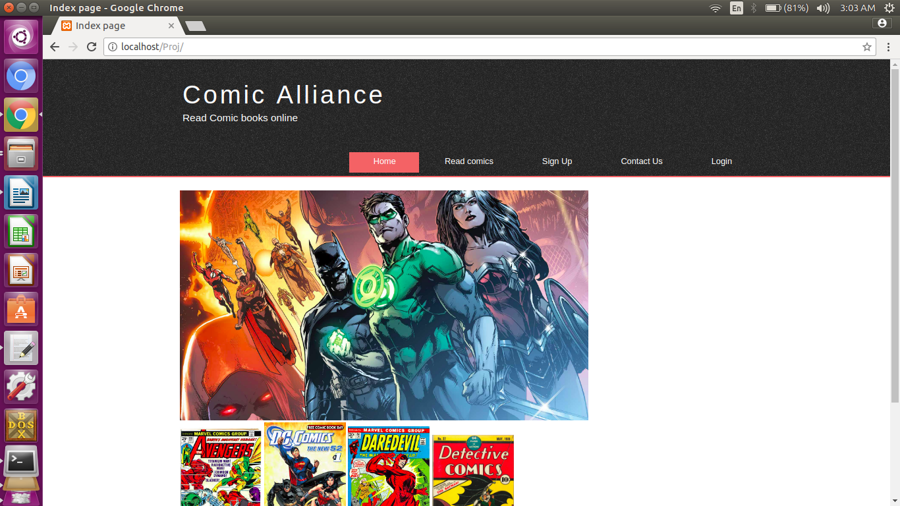**Index.php**

**register.php**

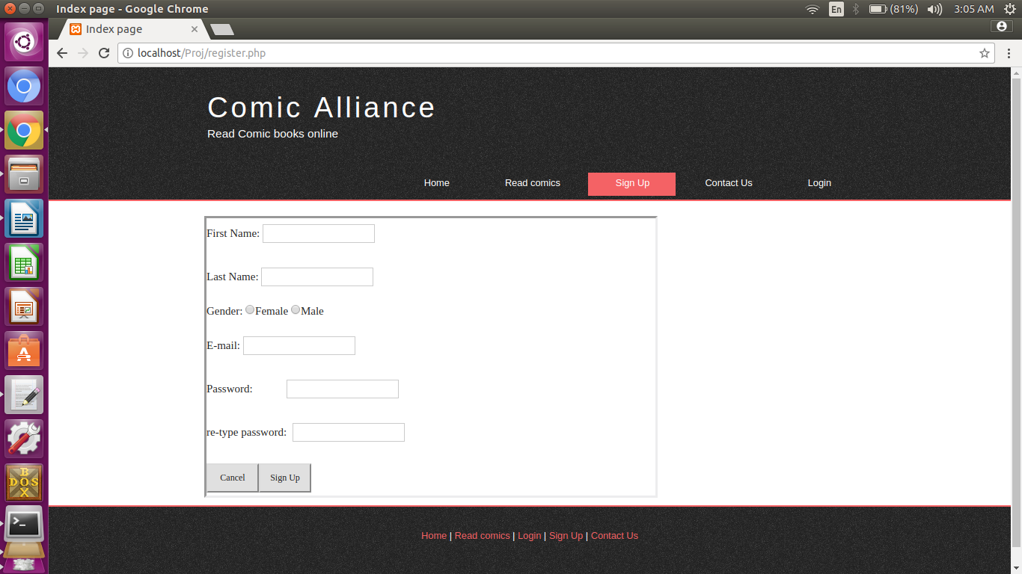

**login.php**

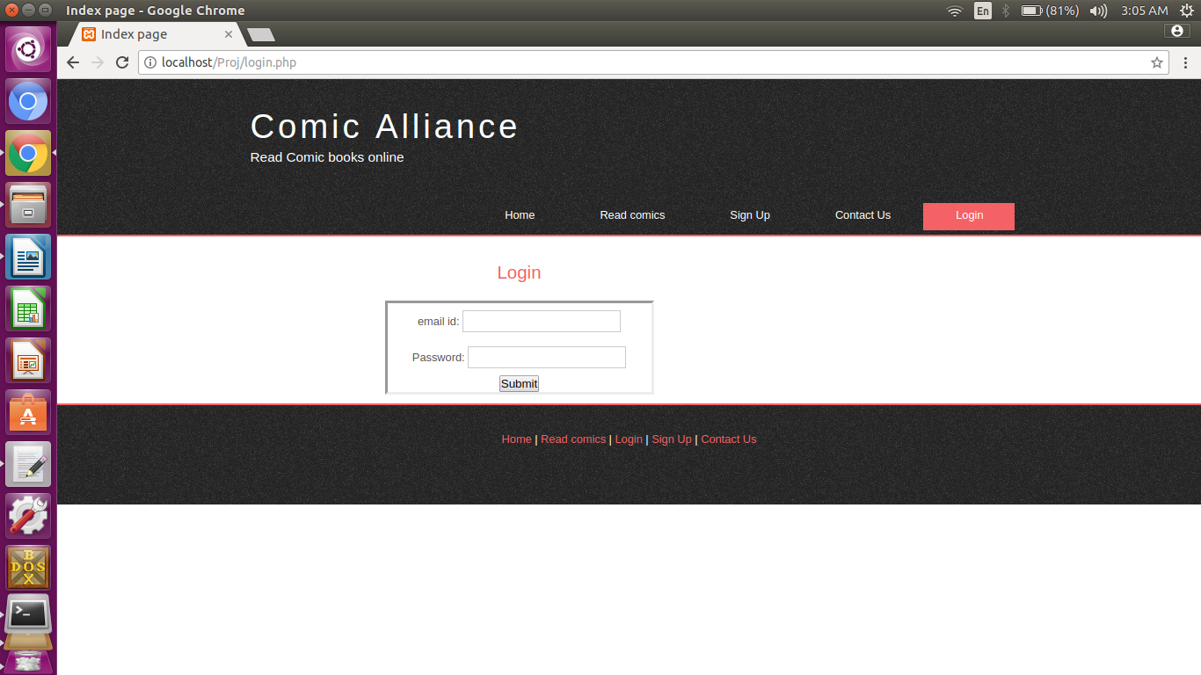

**readsect.php**

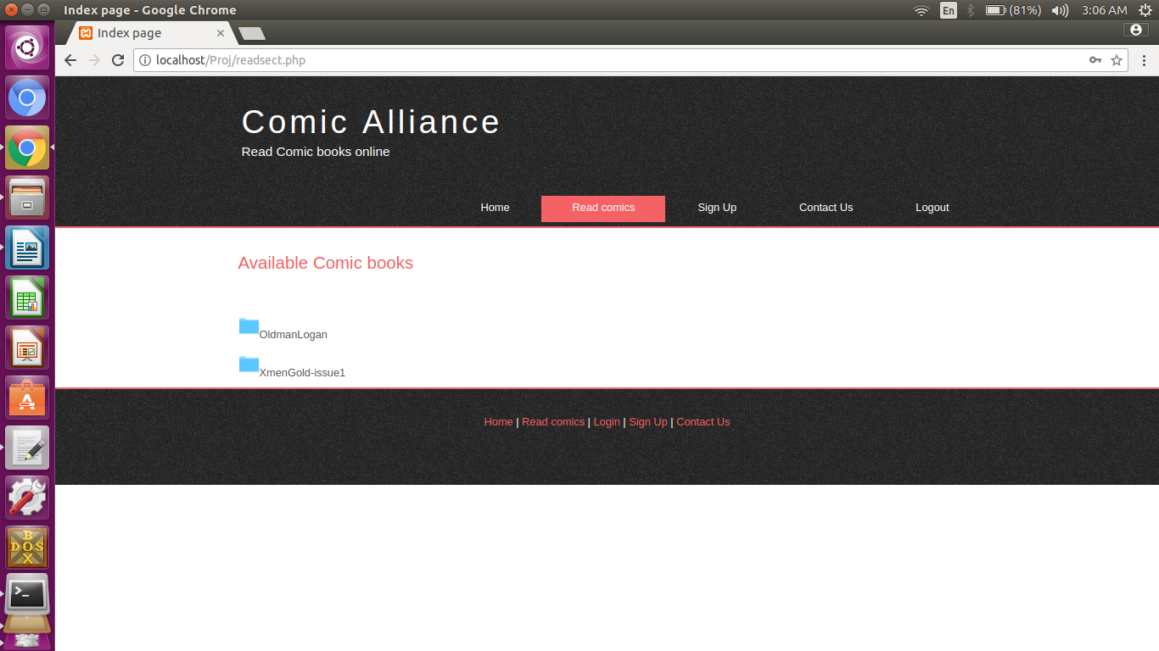

**readcomic.php**

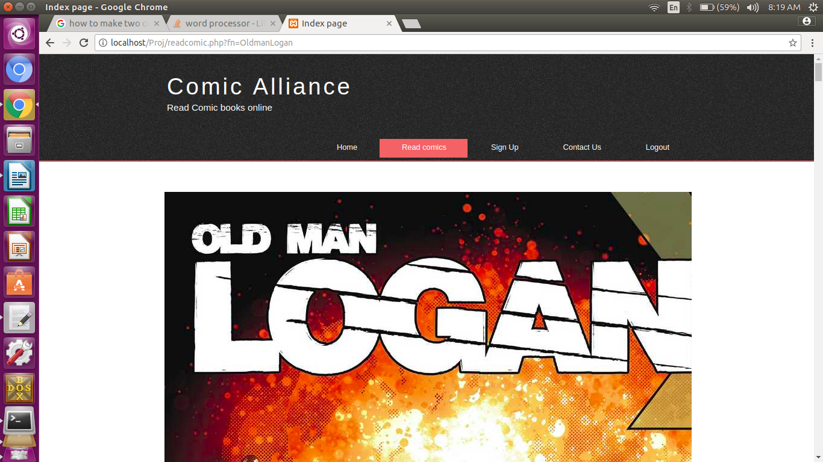

**contact.php**

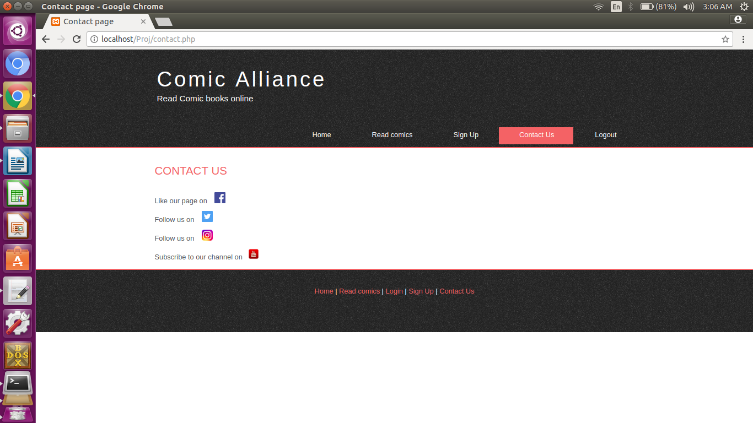

# 7. REFERENCE AND BIBLIOGRAPHY

* [https://www.w3schools.com](https://www.w3schools.com/)
* <https://stackoverflow.com/>

# 8. CONCLUSION

So this website has provided us with new comic reading experience. It is fast and more efficient to use.